INTELLIGENT PLATFORM FOR DISEASE PREDICTION AND HEALTH
Project Submitted to the
BHARATHIDASAN UNIVERSITY, TIRUCHIRAPALLI-24.
in partial fulfilment of the requirements for the award of
BACHELOR DEGREE IN COMPUTER APPLICATIONS
Submitted by

NAME | REGISTER NUMBER
STEFFI CLARA F | 23050410500112076
PHILOMINA L | 23050410500112051
SUJITHA S | 23050410500112078

Under the guidance

Ms. J. Rathna, B.E., M.Tech.,
DEPARTMENT OF COMPUTER APPLICATIONS
SHRIMATI INDIRA GANDHI COLLEGE
(Affiliated to Bharathidasan University)
Nationally Accredited at “A” Grade (4th Cycle) by NAAC
An ISO 9001:2015 Certified Institution
TIRUCHIRAPPALLI – 620 002.
APRIL 2026

CERTIFICATE



Ms.J.Rathna,B.E.,M.Tech.,
Assistant Professor,
Department of Computer Applications
Shrimati Indira Gandhi College,
Tiruchirappalli-620002.

CERTIFICATE
This is to certify that the project work entitled
“INTELLIGENT PLATFORM FOR DISEASE PREDICTION AND HEALTH”
Submitted by

NAME | REGISTER NUMBER
STEFFI CLARA F | 23050410500112076
PHILOMINA L | 23050410500112051
SUJITHA S | 23050410500112078

is a bonafide record of the work done by the above mentioned candidates in partial fulfilment of the requirements for the award of the degree of
“BACHELOR OF COMPUTERAPPLICATIONS” and has been carried out under my guidance during the Sixth semester of the academic year (2025-2026).

Signature of the Signature of the Guide
Academic Director

ACKNOWLEDGEMENT


ACKNOWLEDGEMENT

First and foremost, we express our praise and thanks to Lord Almighty for his manifold blessing showered on right from admission and till the completion of the project work successfully in the temple of learning.

We endow our grateful thanks and deep sense of gratitude to our respected PRINCIPAL Dr. P. GAJALAKSHMI, M.Sc., M.Phil. Ph.D., Shrimati Indira Gandhi College, Tiruchirappalli and the management for providing us all the Support carry out the project.

We express our thanks and deep sense of gratitude to our
ACADEMIC DIRECTOR Dr. S. RETHINAVALLI, MCA., M.Phil., Ph.D., of Computer Applications, Shrimati Indira Gandhi College, Tiruchirappalli for sustained Encouragement shown towards the successful completion of this work.

We express our thanks and deep sense of gratitude to our guide MS.J.RATHNA,B.E.,M.Tech.,Assistant Professor, Department of Computer Applications, for her guidance and encouragement during the course of our study and in successfully accomplishing this project.

We also submitted our heartfelt thanks to our tutor MS.J.RATHNA,B.E.,M.Tech.,
Assistant Professor, Department of Computer Applications, Shrimati Indira Gandhi College Tiruchirappalli for their motivation and support rendered during the tenure of our course.

Viva – Voce Examination

The Project Viva Voce Examination was held on --------------------------

Signature Of Internal Examiner Signature Of External Examiner

CONTENT

1. INTRODUCTION 9
2. SYSTEM ANALYSIS 10
2.2 Proposed System 11
Features of the Proposed System 11
3. SYSTEM CONFIGURATION 12
4. PROJECT DESCRIPTION 13
4.1 Software Description 13
4.2 Modules Description 14
4.3 Dataset Description 16
5.SYSTEM DESIG 43
5.1 Use Case Diagram…………………………………………………………………………………….43
5.2 Data Flow Diagram (DFD)……………………………………………………………………………44
5.3 Sequence Diagram…………………………………………………………………………………….45
6. TESTING 46
6.1 Unit Testing 46
6.2 Integration Testing 48
6.3 System Testing………………………………………………………………………………………...49
7.SOFTWARE IMPLEMENTATION 52
8. CONCLUSION 61
9. FUTURE ENHANCEMENTS 62
10. BIBLIOGRAPHY 63

ABSTRACT

Early detection of diseases plays a vital role in improving patient outcomes and reducing healthcare costs. This project proposes a predictive analytics model that utilizes Electronic Health Record (EHR) data to identify early signs of diseases. Machine learning algorithms such as Logistic Regression, Random Forest, and Support Vector Machines are applied to structured patient data including medical history, lab results, and demographic information. The system analyzes patterns and risk factors to predict potential diseases at an early stage. The model aims to assist healthcare professionals in proactive decision-making, enabling timely diagnosis and preventive care while enhancing the efficiency of clinical workflows.

INTRODUCTION

The Disease Prediction System is a Machine Learning-based web application developed to predict possible diseases based on symptoms selected by the user. The system uses a trained XGBoost classification model along with feature selection techniques to provide accurate predictions.
The application is built using Streamlit, which provides an interactive user interface where users can select symptoms and receive disease predictions along with probability scores.
This project aims to:
- Provide quick disease prediction based on symptoms
- Demonstrate the practical implementation of Machine Learning in healthcare
- Build an interactive web application using Python

2. SYSTEM ANALYSIS
System analysis is the process of studying the current system, identifying its problems, and proposing improvements. In the healthcare domain, early disease identification plays a crucial role in effective treatment and prevention. The traditional disease identification process has several limitations that can be improved using modern technology and machine learning.

2.1 Existing System
In the existing system, disease diagnosis primarily depends on manual methods and professional consultation. The process is mostly traditional and lacks automation or intelligent decision support.

1. Manual Symptom Search
Patients often search their symptoms on the internet using search engines. They type symptoms like "fever and headache" and read articles from various websites.
Problems:
- Information overload
- Conflicting medical advice
- Lack of personalization
- High chance of misunderstanding medical information
Patients may misinterpret symptoms and assume the worst-case scenario, leading to unnecessary stress.

2. Complete Dependence on Doctor Consultation
Diagnosis entirely depends on visiting a doctor or hospital.
Issues:
- Time-consuming process
- Requires appointment booking
- Travel cost and waiting time
- Not always immediately accessible in rural areas
While doctors provide accurate diagnosis, there is no preliminary automated screening system that assists patients before consultation.

2.2 Proposed System
The proposed system is a Machine Learning-based Disease Prediction Web Application developed to provide preliminary disease prediction based on symptoms selected by the user.
Unlike the traditional manual system, the proposed solution uses a trained classification model to analyze symptom patterns and predict the most probable disease along with confidence scores.
The system integrates:
- Machine Learning (XGBoost Classifier)
- Feature Selection Techniques
- Label Encoding
- Streamlit Web Interface
- Probability-based ranking mechanism
This system acts as a decision-support tool and is designed mainly for educational and demonstration purposes.

Working Principle of Proposed System
- User selects symptoms from the available list.
- Selected symptoms are converted into a binary feature vector.
- Feature selection is applied using a trained selector.
- The processed data is given to the trained XGBoost model.
- The model predicts the most probable disease.
- The top 3 predictions are displayed with probability scores.
- If confidence is low, a warning message is shown.

Features of the Proposed System

Symptom Selection using Multi-Select Option
The system provides an interactive multi-select dropdown where users can choose one or more symptoms they are experiencing.
- Prevents invalid symptom entry
- Ensures structured input
- User-friendly interface
- Reduces manual typing errors

3. SYSTEM CONFIGURATION

3.1 Hardware Specification

Component | Specification
Processor | Intel i3
RAM | 8GB
Storage | 20GB free space
System Type | 64-bit OS
Internet | Required for deployment

3.2 Software Specification

Software | Version
Operating System | Windows 11
Python | 3.8+
Streamlit | Latest
XGBoost | Latest
Pandas | Latest
NumPy | Latest
Scikit-learn | Latest
Joblib | Latest
IDE | VS Code / PyCharm

4. PROJECT DESCRIPTION

4.1 Software Description
The system is developed using the following technologies:

Python
Python is the core programming language used for implementing data processing, model prediction, and backend logic. It supports all required machine learning and web development libraries.

XGBoost
XGBoost is used as the classification algorithm for predicting diseases. It is a powerful gradient boosting algorithm known for:
- High accuracy
- Fast performance
- Efficient handling of multi-class classification
The trained model is saved as:
xgb_model.pkl

Scikit-learn
Scikit-learn is used for preprocessing tasks such as:
- Feature Selection – Removes less important features to improve prediction performance.
Saved as: selector.pkl
- Label Encoding – Converts disease names into numerical form during training and converts predictions back to readable disease names.
Saved as: label_encoder.pkl

Joblib
Joblib is used to save and load the trained model and preprocessing components.
It ensures:
- Faster loading
- No need to retrain the model each time
The following files are loaded using joblib.load() in the Streamlit application:
- xgb_model.pkl
- selector.pkl
- label_encoder.pkl
- binary_features_columns.pkl

Streamlit
Streamlit is used to build the web interface of the application. It provides:
- Multi-select symptom selection
- Predict button
- Real-time result display
- Clean and simple UI
It connects the backend model with the frontend interface.

Pandas and NumPy
- Pandas is used to create and manage structured input data.
- NumPy is used for numerical computations and probability handling.

Model Loading Process
When the application starts:
- The trained model and preprocessing objects are loaded.
- Streamlit caching ensures they are loaded only once for better performance.
- The system is then ready for real-time prediction.

4.2 Modules Description
The Disease Prediction System is divided into several functional modules. Each module performs a specific task to ensure smooth operation of the application. The modular structure improves maintainability, scalability, and clarity of the system design.

Model Loading Module
This module is responsible for loading the trained machine learning model and preprocessing components when the application starts.

Functions:
- Loads xgb_model.pkl (trained XGBoost model)
- Loads selector.pkl (feature selector)
- Loads label_encoder.pkl (label encoder)
- Loads binary_features_columns.pkl (symptom feature list)
Streamlit’s @st.cache_resource decorator is used to:
- Load the model only once
- Improve performance
- Reduce repeated memory usage
This ensures faster predictions during user interaction.

User Interface Module
This module handles the frontend interaction with the user using Streamlit.

Functions:
- Displays application title and description
- Provides a multi-select dropdown for symptom selection
- Displays a "Predict Disease" button
The interface is designed to be:
- Simple and user-friendly
- Interactive
- Accessible through a web browser

Input Processing Module
This module processes the user-selected symptoms before sending them to the model.

Functions:
- Creates a binary feature vector (1 for selected symptoms, 0 for others)
- Converts the vector into a Pandas DataFrame
- Applies the trained feature selector to match the model’s expected input format
This ensures the input structure is identical to the training data format.

Prediction Module
This module performs the core machine learning prediction.

Functions:
- Uses model.predict() to determine the most likely disease
- Uses model.predict_proba() to calculate probability scores
- Sorts diseases based on highest probability
The module ensures that predictions are data-driven and statistically calculated.

Result Display Module
This module presents the prediction results to the user.

Functions:
- Displays the predicted disease using st.success()
- Shows the top 3 diseases with probability percentages
- Displays a confidence warning if the highest probability is below 50%
This improves transparency and helps users understand the reliability of the prediction.

Disclaimer Module
This module displays a medical disclaimer at the bottom of the application.Purpose:
- Clarifies that the system is for educational purposes only
- Advises users to consult medical professionals
- Promotes responsible AI usage

4.3 Dataset Description
The dataset used for the Disease Prediction System is a structured symptom-disease dataset. It contains various diseases along with their associated symptoms. The dataset is used to train the machine learning model to predict diseases based on symptom combinations.

Dataset Structure
The dataset is stored in CSV (Comma Separated Values) format and consists of the following columns:
- Disease – Target variable (Disease name)
- Symptom_1
- Symptom_2
- Symptom_3
- Symptom_4
Each row represents a disease and its corresponding symptom combination.

Sample Dataset Format

Symptom_1 | Symptom_2 | Symptom_3
itching | skin_rash | nodal_skin_eruptions
skin_rash | nodal_skin_eruptions | dischromic _patches
itching | nodal_skin_eruptions | dischromic _patches
itching | skin_rash | dischromic _patches
itching | skin_rash | nodal_skin_eruptions
skin_rash | nodal_skin_eruptions | dischromic _patches
itching | nodal_skin_eruptions | dischromic _patches
itching | skin_rash | dischromic _patches
itching | skin_rash | nodal_skin_eruptions
itching | skin_rash | nodal_skin_eruptions
continuous_sneezing | shivering | chills
shivering | chills | watering_from_eyes
continuous_sneezing | chills | watering_from_eyes
continuous_sneezing | shivering | watering_from_eyes
continuous_sneezing | shivering | chills
shivering | chills | watering_from_eyes
continuous_sneezing | chills | watering_from_eyes
continuous_sneezing | shivering | watering_from_eyes
continuous_sneezing | shivering | chills
continuous_sneezing | shivering | chills
stomach_pain | acidity | ulcers_on_tongue
stomach_pain | ulcers_on_tongue | vomiting
stomach_pain | acidity | vomiting
stomach_pain | acidity | ulcers_on_tongue
stomach_pain | acidity | ulcers_on_tongue
stomach_pain | acidity | ulcers_on_tongue
acidity | ulcers_on_tongue | vomiting
stomach_pain | ulcers_on_tongue | vomiting
stomach_pain | acidity | vomiting
stomach_pain | acidity | ulcers_on_tongue
itching | vomiting | yellowish_skin
vomiting | yellowish_skin | nausea
itching | yellowish_skin | nausea
itching | vomiting | nausea
itching | vomiting | yellowish_skin
itching | vomiting | yellowish_skin
itching | vomiting | yellowish_skin
itching | vomiting | yellowish_skin
itching | vomiting | yellowish_skin
itching | vomiting | yellowish_skin
itching | skin_rash | stomach_pain
itching | stomach_pain | burning_micturition
itching | skin_rash | burning_micturition
itching | skin_rash | stomach_pain
itching | skin_rash | stomach_pain
skin_rash | stomach_pain | burning_micturition
itching | stomach_pain | burning_micturition
itching | skin_rash | burning_micturition
itching | skin_rash | stomach_pain
itching | skin_rash | stomach_pain
vomiting | loss_of_appetite | abdominal_pain
vomiting | indigestion | abdominal_pain
indigestion | loss_of_appetite | abdominal_pain
vomiting | loss_of_appetite | abdominal_pain
vomiting | indigestion | abdominal_pain
vomiting | indigestion | loss_of_appetite
vomiting | indigestion | loss_of_appetite
vomiting | indigestion | loss_of_appetite
vomiting | indigestion | loss_of_appetite
vomiting | indigestion | loss_of_appetite
muscle_wasting | patches_in_throat | high_fever
patches_in_throat | high_fever | extra_marital_contacts
muscle_wasting | high_fever | extra_marital_contacts
muscle_wasting | patches_in_throat | extra_marital_contacts
muscle_wasting | patches_in_throat | high_fever
muscle_wasting | patches_in_throat | high_fever
muscle_wasting | patches_in_throat | high_fever
patches_in_throat | high_fever | extra_marital_contacts
muscle_wasting | high_fever | extra_marital_contacts
muscle_wasting | patches_in_throat | high_fever
fatigue | weight_loss | restlessness
fatigue | weight_loss | restlessness
weight_loss | restlessness | lethargy
fatigue | restlessness | lethargy
fatigue | weight_loss | lethargy
fatigue | weight_loss | restlessness
fatigue | weight_loss | restlessness
fatigue | weight_loss | restlessness
fatigue | weight_loss | restlessness
fatigue | weight_loss | restlessness
vomiting | sunken_eyes | dehydration
vomiting | sunken_eyes | dehydration
sunken_eyes | dehydration | diarrhoea
vomiting | dehydration | diarrhoea
vomiting | sunken_eyes | diarrhoea
vomiting | sunken_eyes | dehydration
vomiting | sunken_eyes | dehydration
sunken_eyes | dehydration | diarrhoea
vomiting | dehydration | diarrhoea
vomiting | sunken_eyes | diarrhoea
fatigue | cough | high_fever
cough | high_fever | breathlessness
fatigue | high_fever | breathlessness
fatigue | cough | breathlessness
fatigue | cough | high_fever
fatigue | cough | high_fever
fatigue | cough | high_fever
fatigue | cough | high_fever
cough | high_fever | breathlessness
fatigue | high_fever | breathlessness
headache | chest_pain | dizziness
chest_pain | dizziness | loss_of_balance
headache | dizziness | loss_of_balance
headache | chest_pain | loss_of_balance
headache | chest_pain | dizziness
headache | chest_pain | dizziness
headache | chest_pain | dizziness
chest_pain | dizziness | loss_of_balance
headache | dizziness | loss_of_balance
headache | chest_pain | loss_of_balance
acidity | indigestion | headache
indigestion | headache | blurred_and_distorted_vision
acidity | headache | blurred_and_distorted_vision
acidity | indigestion | blurred_and_distorted_vision
acidity | indigestion | headache
acidity | indigestion | headache
acidity | indigestion | headache
acidity | indigestion | headache
acidity | indigestion | headache
acidity | indigestion | headache
back_pain | weakness_in_limbs | neck_pain
back_pain | weakness_in_limbs | neck_pain
weakness_in_limbs | neck_pain | dizziness
back_pain | neck_pain | dizziness
back_pain | weakness_in_limbs | dizziness
back_pain | weakness_in_limbs | neck_pain
back_pain | weakness_in_limbs | neck_pain
back_pain | weakness_in_limbs | neck_pain
weakness_in_limbs | neck_pain | dizziness
back_pain | neck_pain | dizziness
vomiting | headache | weakness_of_one_body_side
vomiting | headache | weakness_of_one_body_side
headache | weakness_of_one_body_side | altered_sensorium
vomiting | weakness_of_one_body_side | altered_sensorium
vomiting | headache | altered_sensorium
vomiting | headache | weakness_of_one_body_side
vomiting | headache | weakness_of_one_body_side
headache | weakness_of_one_body_side | altered_sensorium
vomiting | weakness_of_one_body_side | altered_sensorium
vomiting | headache | altered_sensorium
itching | vomiting | fatigue
itching | vomiting | fatigue
vomiting | fatigue | weight_loss
itching | fatigue | weight_loss
itching | vomiting | weight_loss
itching | vomiting | fatigue
itching | vomiting | fatigue
itching | vomiting | fatigue
itching | vomiting | fatigue
itching | vomiting | fatigue
chills | vomiting | high_fever
chills | vomiting | high_fever
chills | vomiting | high_fever
vomiting | high_fever | sweating
chills | high_fever | sweating
chills | vomiting | sweating
chills | vomiting | high_fever
chills | vomiting | high_fever
chills | vomiting | high_fever
chills | vomiting | high_fever
itching | skin_rash | fatigue
skin_rash | fatigue | lethargy
itching | fatigue | lethargy
itching | skin_rash | lethargy
itching | skin_rash | fatigue
itching | skin_rash | fatigue
itching | skin_rash | fatigue
itching | skin_rash | fatigue
itching | skin_rash | fatigue
itching | skin_rash | fatigue
skin_rash | chills | joint_pain
skin_rash | chills | joint_pain
skin_rash | chills | joint_pain
skin_rash | chills | joint_pain
chills | joint_pain | vomiting
skin_rash | joint_pain | vomiting
skin_rash | chills | vomiting
skin_rash | chills | joint_pain
skin_rash | chills | joint_pain
skin_rash | chills | joint_pain
chills | vomiting | fatigue
chills | vomiting | fatigue
chills | vomiting | fatigue
chills | vomiting | fatigue
chills | vomiting | fatigue
chills | vomiting | fatigue
chills | vomiting | fatigue
chills | vomiting | fatigue
chills | vomiting | fatigue
chills | fatigue | high_fever
joint_pain | vomiting | yellowish_skin
joint_pain | vomiting | yellowish_skin
vomiting | yellowish_skin | dark_urine
joint_pain | yellowish_skin | dark_urine
joint_pain | vomiting | dark_urine
joint_pain | vomiting | yellowish_skin
joint_pain | vomiting | yellowish_skin
joint_pain | vomiting | yellowish_skin
joint_pain | vomiting | yellowish_skin
joint_pain | vomiting | yellowish_skin
itching | fatigue | lethargy
itching | fatigue | lethargy
fatigue | lethargy | yellowish_skin
itching | lethargy | yellowish_skin
itching | fatigue | yellowish_skin
itching | fatigue | lethargy
itching | fatigue | lethargy
itching | fatigue | lethargy
itching | fatigue | lethargy
itching | fatigue | lethargy
fatigue | yellowish_skin | nausea
fatigue | yellowish_skin | nausea
yellowish_skin | nausea | loss_of_appetite
fatigue | nausea | loss_of_appetite
fatigue | yellowish_skin | loss_of_appetite
fatigue | yellowish_skin | nausea
fatigue | yellowish_skin | nausea
fatigue | yellowish_skin | nausea
fatigue | yellowish_skin | nausea
fatigue | yellowish_skin | nausea
joint_pain | vomiting | fatigue
vomiting | fatigue | yellowish_skin
joint_pain | fatigue | yellowish_skin
joint_pain | vomiting | yellowish_skin
joint_pain | vomiting | fatigue
joint_pain | vomiting | fatigue
joint_pain | vomiting | fatigue
joint_pain | vomiting | fatigue
joint_pain | vomiting | fatigue
joint_pain | vomiting | fatigue
joint_pain | vomiting | fatigue
joint_pain | vomiting | fatigue
joint_pain | vomiting | fatigue
vomiting | fatigue | high_fever
joint_pain | fatigue | high_fever
joint_pain | vomiting | high_fever
joint_pain | vomiting | fatigue
joint_pain | vomiting | fatigue
joint_pain | vomiting | fatigue
joint_pain | vomiting | fatigue
vomiting | yellowish_skin | abdominal_pain
vomiting | yellowish_skin | abdominal_pain
yellowish_skin | abdominal_pain | swelling_of_stomach
vomiting | abdominal_pain | swelling_of_stomach
vomiting | yellowish_skin | swelling_of_stomach
vomiting | yellowish_skin | abdominal_pain
vomiting | yellowish_skin | abdominal_pain
vomiting | yellowish_skin | abdominal_pain
vomiting | yellowish_skin | abdominal_pain
vomiting | yellowish_skin | abdominal_pain
chills | vomiting | fatigue
chills | vomiting | fatigue
vomiting | fatigue | weight_loss
chills | fatigue | weight_loss
chills | vomiting | weight_loss
chills | vomiting | fatigue
chills | vomiting | fatigue
chills | vomiting | fatigue
chills | vomiting | fatigue
chills | vomiting | fatigue
continuous_sneezing | chills | fatigue
continuous_sneezing | chills | fatigue
chills | fatigue | cough
continuous_sneezing | fatigue | cough
continuous_sneezing | chills | cough
continuous_sneezing | chills | fatigue
continuous_sneezing | chills | fatigue
continuous_sneezing | chills | fatigue
continuous_sneezing | chills | fatigue
continuous_sneezing | chills | fatigue
chills | fatigue | cough
chills | fatigue | cough
chills | fatigue | cough
fatigue | cough | high_fever
chills | cough | high_fever
chills | fatigue | high_fever
chills | fatigue | cough
chills | fatigue | cough
chills | fatigue | cough
chills | fatigue | cough
constipation | pain_during_bowel_movements | pain_in_anal_region
constipation | pain_during_bowel_movements | pain_in_anal_region
constipation | pain_during_bowel_movements | pain_in_anal_region
pain_during_bowel_movements | pain_in_anal_region | bloody_stool
constipation | pain_in_anal_region | bloody_stool
constipation | pain_during_bowel_movements | bloody_stool
constipation | pain_during_bowel_movements | pain_in_anal_region
constipation | pain_during_bowel_movements | pain_in_anal_region
constipation | pain_during_bowel_movements | pain_in_anal_region
constipation | pain_during_bowel_movements | pain_in_anal_region
vomiting | breathlessness | sweating
vomiting | breathlessness | sweating
breathlessness | sweating | chest_pain
vomiting | sweating | chest_pain
vomiting | breathlessness | chest_pain
vomiting | breathlessness | sweating
vomiting | breathlessness | sweating
breathlessness | sweating | chest_pain
vomiting | sweating | chest_pain
vomiting | breathlessness | chest_pain
fatigue | cramps | bruising
fatigue | cramps | bruising
cramps | bruising | obesity
fatigue | bruising | obesity
fatigue | cramps | obesity
fatigue | cramps | bruising
fatigue | cramps | bruising
fatigue | cramps | bruising
fatigue | cramps | bruising
fatigue | cramps | bruising
fatigue | weight_gain | cold_hands_and_feets
fatigue | weight_gain | cold_hands_and_feets
weight_gain | cold_hands_and_feets | mood_swings
weight_gain | cold_hands_and_feets | mood_swings
fatigue | cold_hands_and_feets | mood_swings
fatigue | weight_gain | mood_swings
fatigue | weight_gain | cold_hands_and_feets
fatigue | weight_gain | cold_hands_and_feets
fatigue | weight_gain | cold_hands_and_feets
fatigue | weight_gain | cold_hands_and_feets
fatigue | mood_swings | weight_loss
fatigue | mood_swings | weight_loss
mood_swings | weight_loss | restlessness
fatigue | weight_loss | restlessness
fatigue | mood_swings | restlessness
fatigue | mood_swings | weight_loss
fatigue | mood_swings | weight_loss
fatigue | mood_swings | weight_loss
fatigue | mood_swings | weight_loss
fatigue | mood_swings | weight_loss
vomiting | fatigue | anxiety
vomiting | fatigue | anxiety
vomiting | fatigue | anxiety
fatigue | anxiety | sweating
vomiting | anxiety | sweating
vomiting | fatigue | sweating
vomiting | fatigue | anxiety
vomiting | fatigue | anxiety
vomiting | fatigue | anxiety
vomiting | fatigue | anxiety
joint_pain | neck_pain | knee_pain
joint_pain | neck_pain | knee_pain
neck_pain | knee_pain | hip_joint_pain
joint_pain | knee_pain | hip_joint_pain
joint_pain | neck_pain | hip_joint_pain
joint_pain | neck_pain | knee_pain
joint_pain | neck_pain | knee_pain
joint_pain | neck_pain | knee_pain
joint_pain | neck_pain | knee_pain
joint_pain | neck_pain | knee_pain
muscle_weakness | stiff_neck | swelling_joints
muscle_weakness | stiff_neck | swelling_joints
stiff_neck | swelling_joints | movement_stiffness
muscle_weakness | swelling_joints | movement_stiffness
muscle_weakness | stiff_neck | movement_stiffness
muscle_weakness | stiff_neck | swelling_joints
muscle_weakness | stiff_neck | swelling_joints
muscle_weakness | stiff_neck | swelling_joints
muscle_weakness | stiff_neck | swelling_joints
muscle_weakness | stiff_neck | swelling_joints
vomiting | headache | nausea
vomiting | headache | nausea
headache | nausea | spinning_movements
vomiting | nausea | spinning_movements
vomiting | headache | spinning_movements
vomiting | headache | nausea
vomiting | headache | nausea
vomiting | headache | nausea
vomiting | headache | nausea
vomiting | headache | nausea
skin_rash | pus_filled_pimples | blackheads
skin_rash | pus_filled_pimples | blackheads
pus_filled_pimples | blackheads | scurring
skin_rash | blackheads | scurring
skin_rash | pus_filled_pimples | scurring
skin_rash | pus_filled_pimples | blackheads
skin_rash | pus_filled_pimples | blackheads
skin_rash | pus_filled_pimples | blackheads
skin_rash | pus_filled_pimples | scurring
skin_rash | blackheads | scurring
burning_micturition | bladder_discomfort | foul_smell_of urine
burning_micturition | bladder_discomfort | foul_smell_of urine
bladder_discomfort | foul_smell_of urine | continuous_feel_of_urine
burning_micturition | foul_smell_of urine | continuous_feel_of_urine
burning_micturition | bladder_discomfort | continuous_feel_of_urine
burning_micturition | bladder_discomfort | foul_smell_of urine
burning_micturition | bladder_discomfort | foul_smell_of urine
burning_micturition | bladder_discomfort | continuous_feel_of_urine
bladder_discomfort | foul_smell_of urine | continuous_feel_of_urine
burning_micturition | bladder_discomfort | continuous_feel_of_urine
skin_rash | joint_pain | skin_peeling
skin_rash | joint_pain | skin_peeling
joint_pain | skin_peeling | silver_like_dusting
skin_rash | skin_peeling | silver_like_dusting
skin_rash | joint_pain | silver_like_dusting
skin_rash | joint_pain | skin_peeling
skin_rash | joint_pain | skin_peeling
skin_rash | joint_pain | skin_peeling
skin_rash | joint_pain | skin_peeling
skin_rash | joint_pain | skin_peeling
skin_rash | high_fever | blister
skin_rash | high_fever | blister
high_fever | blister | red_sore_around_nose
skin_rash | blister | red_sore_around_nose
skin_rash | blister | red_sore_around_nose
skin_rash | high_fever | red_sore_around_nose
skin_rash | high_fever | blister
skin_rash | high_fever | blister
skin_rash | high_fever | blister
skin_rash | blister | red_sore_around_nose
itching | skin_rash | nodal_skin_eruptions
skin_rash | nodal_skin_eruptions | dischromic _patches
itching | nodal_skin_eruptions | dischromic _patches
itching | skin_rash | dischromic _patches
itching | skin_rash | nodal_skin_eruptions
skin_rash | nodal_skin_eruptions | dischromic _patches
itching | nodal_skin_eruptions | dischromic _patches
itching | skin_rash | dischromic _patches
itching | skin_rash | nodal_skin_eruptions
itching | skin_rash | nodal_skin_eruptions
continuous_sneezing | shivering | chills
shivering | chills | watering_from_eyes
continuous_sneezing | chills | watering_from_eyes
continuous_sneezing | shivering | watering_from_eyes
continuous_sneezing | shivering | chills
shivering | chills | watering_from_eyes
continuous_sneezing | chills | watering_from_eyes
continuous_sneezing | shivering | watering_from_eyes
continuous_sneezing | shivering | chills
continuous_sneezing | shivering | chills
stomach_pain | acidity | ulcers_on_tongue
stomach_pain | ulcers_on_tongue | vomiting
stomach_pain | acidity | vomiting
stomach_pain | acidity | ulcers_on_tongue
stomach_pain | acidity | ulcers_on_tongue
stomach_pain | acidity | ulcers_on_tongue
acidity | ulcers_on_tongue | vomiting
stomach_pain | ulcers_on_tongue | vomiting
stomach_pain | acidity | vomiting
stomach_pain | acidity | ulcers_on_tongue
itching | vomiting | yellowish_skin
vomiting | yellowish_skin | nausea
itching | yellowish_skin | nausea
itching | vomiting | nausea
itching | vomiting | yellowish_skin
itching | vomiting | yellowish_skin
itching | vomiting | yellowish_skin
itching | vomiting | yellowish_skin
itching | vomiting | yellowish_skin
itching | vomiting | yellowish_skin
itching | skin_rash | stomach_pain
itching | stomach_pain | burning_micturition
itching | skin_rash | burning_micturition
itching | skin_rash | stomach_pain
itching | skin_rash | stomach_pain
skin_rash | stomach_pain | burning_micturition
itching | stomach_pain | burning_micturition
itching | skin_rash | burning_micturition
itching | skin_rash | stomach_pain
itching | skin_rash | stomach_pain
vomiting | loss_of_appetite | abdominal_pain
vomiting | indigestion | abdominal_pain
indigestion | loss_of_appetite | abdominal_pain
vomiting | loss_of_appetite | abdominal_pain
vomiting | indigestion | abdominal_pain
vomiting | indigestion | loss_of_appetite
vomiting | indigestion | loss_of_appetite
vomiting | indigestion | loss_of_appetite
vomiting | indigestion | loss_of_appetite
vomiting | indigestion | loss_of_appetite
muscle_wasting | patches_in_throat | high_fever
patches_in_throat | high_fever | extra_marital_contacts
muscle_wasting | high_fever | extra_marital_contacts
muscle_wasting | patches_in_throat | extra_marital_contacts
muscle_wasting | patches_in_throat | high_fever
muscle_wasting | patches_in_throat | high_fever
muscle_wasting | patches_in_throat | high_fever
patches_in_throat | high_fever | extra_marital_contacts
muscle_wasting | high_fever | extra_marital_contacts
muscle_wasting | patches_in_throat | high_fever
fatigue | weight_loss | restlessness
fatigue | weight_loss | restlessness
weight_loss | restlessness | lethargy
fatigue | restlessness | lethargy
fatigue | weight_loss | lethargy
fatigue | weight_loss | restlessness
fatigue | weight_loss | restlessness
fatigue | weight_loss | restlessness
fatigue | weight_loss | restlessness
fatigue | weight_loss | restlessness
vomiting | sunken_eyes | dehydration
vomiting | sunken_eyes | dehydration
sunken_eyes | dehydration | diarrhoea
vomiting | dehydration | diarrhoea
vomiting | sunken_eyes | diarrhoea
vomiting | sunken_eyes | dehydration
vomiting | sunken_eyes | dehydration
sunken_eyes | dehydration | diarrhoea
vomiting | dehydration | diarrhoea
vomiting | sunken_eyes | diarrhoea
fatigue | cough | high_fever
cough | high_fever | breathlessness
fatigue | high_fever | breathlessness
fatigue | cough | breathlessness
fatigue | cough | high_fever
fatigue | cough | high_fever
fatigue | cough | high_fever
fatigue | cough | high_fever
cough | high_fever | breathlessness
fatigue | high_fever | breathlessness
headache | chest_pain | dizziness
chest_pain | dizziness | loss_of_balance
headache | dizziness | loss_of_balance
headache | chest_pain | loss_of_balance
headache | chest_pain | dizziness
headache | chest_pain | dizziness
headache | chest_pain | dizziness
chest_pain | dizziness | loss_of_balance
headache | dizziness | loss_of_balance
headache | chest_pain | loss_of_balance
acidity | indigestion | headache
indigestion | headache | blurred_and_distorted_vision
acidity | headache | blurred_and_distorted_vision
acidity | indigestion | blurred_and_distorted_vision
acidity | indigestion | headache
acidity | indigestion | headache
acidity | indigestion | headache
acidity | indigestion | headache
acidity | indigestion | headache
acidity | indigestion | headache
back_pain | weakness_in_limbs | neck_pain
back_pain | weakness_in_limbs | neck_pain
weakness_in_limbs | neck_pain | dizziness
back_pain | neck_pain | dizziness
back_pain | weakness_in_limbs | dizziness
back_pain | weakness_in_limbs | neck_pain
back_pain | weakness_in_limbs | neck_pain
back_pain | weakness_in_limbs | neck_pain
weakness_in_limbs | neck_pain | dizziness
back_pain | neck_pain | dizziness
vomiting | headache | weakness_of_one_body_side
vomiting | headache | weakness_of_one_body_side
headache | weakness_of_one_body_side | altered_sensorium
vomiting | weakness_of_one_body_side | altered_sensorium
vomiting | headache | altered_sensorium
vomiting | headache | weakness_of_one_body_side
vomiting | headache | weakness_of_one_body_side
headache | weakness_of_one_body_side | altered_sensorium
vomiting | weakness_of_one_body_side | altered_sensorium
vomiting | headache | altered_sensorium
itching | vomiting | fatigue
itching | vomiting | fatigue
vomiting | fatigue | weight_loss
itching | fatigue | weight_loss
itching | vomiting | weight_loss
itching | vomiting | fatigue
itching | vomiting | fatigue
itching | vomiting | fatigue
itching | vomiting | fatigue
itching | vomiting | fatigue
chills | vomiting | high_fever
chills | vomiting | high_fever
chills | vomiting | high_fever
vomiting | high_fever | sweating
chills | high_fever | sweating
chills | vomiting | sweating
chills | vomiting | high_fever
chills | vomiting | high_fever
chills | vomiting | high_fever
chills | vomiting | high_fever
itching | skin_rash | fatigue
skin_rash | fatigue | lethargy
itching | fatigue | lethargy
itching | skin_rash | lethargy
itching | skin_rash | fatigue
itching | skin_rash | fatigue
itching | skin_rash | fatigue
itching | skin_rash | fatigue
itching | skin_rash | fatigue
itching | skin_rash | fatigue
skin_rash | chills | joint_pain
skin_rash | chills | joint_pain
skin_rash | chills | joint_pain
skin_rash | chills | joint_pain
chills | joint_pain | vomiting
skin_rash | joint_pain | vomiting
skin_rash | chills | vomiting
skin_rash | chills | joint_pain
skin_rash | chills | joint_pain
skin_rash | chills | joint_pain
chills | vomiting | fatigue
chills | vomiting | fatigue
chills | vomiting | fatigue
chills | vomiting | fatigue
chills | vomiting | fatigue
chills | vomiting | fatigue
chills | vomiting | fatigue
chills | vomiting | fatigue
chills | vomiting | fatigue
chills | fatigue | high_fever
joint_pain | vomiting | yellowish_skin
joint_pain | vomiting | yellowish_skin
vomiting | yellowish_skin | dark_urine
joint_pain | yellowish_skin | dark_urine
joint_pain | vomiting | dark_urine
joint_pain | vomiting | yellowish_skin
joint_pain | vomiting | yellowish_skin
joint_pain | vomiting | yellowish_skin
joint_pain | vomiting | yellowish_skin
joint_pain | vomiting | yellowish_skin
itching | fatigue | lethargy
itching | fatigue | lethargy
fatigue | lethargy | yellowish_skin
itching | lethargy | yellowish_skin
itching | fatigue | yellowish_skin
itching | fatigue | lethargy
itching | fatigue | lethargy
itching | fatigue | lethargy
itching | fatigue | lethargy
itching | fatigue | lethargy
fatigue | yellowish_skin | nausea
fatigue | yellowish_skin | nausea
yellowish_skin | nausea | loss_of_appetite
fatigue | nausea | loss_of_appetite
fatigue | yellowish_skin | loss_of_appetite
fatigue | yellowish_skin | nausea
fatigue | yellowish_skin | nausea
fatigue | yellowish_skin | nausea
fatigue | yellowish_skin | nausea
fatigue | yellowish_skin | nausea
joint_pain | vomiting | fatigue
vomiting | fatigue | yellowish_skin
joint_pain | fatigue | yellowish_skin
joint_pain | vomiting | yellowish_skin
joint_pain | vomiting | fatigue
joint_pain | vomiting | fatigue
joint_pain | vomiting | fatigue
joint_pain | vomiting | fatigue
joint_pain | vomiting | fatigue
joint_pain | vomiting | fatigue
joint_pain | vomiting | fatigue
joint_pain | vomiting | fatigue
joint_pain | vomiting | fatigue
vomiting | fatigue | high_fever
joint_pain | fatigue | high_fever
joint_pain | vomiting | high_fever
joint_pain | vomiting | fatigue
joint_pain | vomiting | fatigue
joint_pain | vomiting | fatigue
joint_pain | vomiting | fatigue
vomiting | yellowish_skin | abdominal_pain
vomiting | yellowish_skin | abdominal_pain
yellowish_skin | abdominal_pain | swelling_of_stomach
vomiting | abdominal_pain | swelling_of_stomach
vomiting | yellowish_skin | swelling_of_stomach
vomiting | yellowish_skin | abdominal_pain
vomiting | yellowish_skin | abdominal_pain
vomiting | yellowish_skin | abdominal_pain
vomiting | yellowish_skin | abdominal_pain
vomiting | yellowish_skin | abdominal_pain
chills | vomiting | fatigue
chills | vomiting | fatigue
vomiting | fatigue | weight_loss
chills | fatigue | weight_loss
chills | vomiting | weight_loss
chills | vomiting | fatigue
chills | vomiting | fatigue
chills | vomiting | fatigue
chills | vomiting | fatigue
chills | vomiting | fatigue
continuous_sneezing | chills | fatigue
continuous_sneezing | chills | fatigue
chills | fatigue | cough
continuous_sneezing | fatigue | cough
continuous_sneezing | chills | cough
continuous_sneezing | chills | fatigue
continuous_sneezing | chills | fatigue
continuous_sneezing | chills | fatigue
continuous_sneezing | chills | fatigue
continuous_sneezing | chills | fatigue
chills | fatigue | cough
chills | fatigue | cough
chills | fatigue | cough
fatigue | cough | high_fever
chills | cough | high_fever
chills | fatigue | high_fever
chills | fatigue | cough
chills | fatigue | cough
chills | fatigue | cough
chills | fatigue | cough
constipation | pain_during_bowel_movements | pain_in_anal_region
constipation | pain_during_bowel_movements | pain_in_anal_region
constipation | pain_during_bowel_movements | pain_in_anal_region
pain_during_bowel_movements | pain_in_anal_region | bloody_stool
constipation | pain_in_anal_region | bloody_stool
constipation | pain_during_bowel_movements | bloody_stool
constipation | pain_during_bowel_movements | pain_in_anal_region
constipation | pain_during_bowel_movements | pain_in_anal_region
constipation | pain_during_bowel_movements | pain_in_anal_region
constipation | pain_during_bowel_movements | pain_in_anal_region
vomiting | breathlessness | sweating
vomiting | breathlessness | sweating
breathlessness | sweating | chest_pain
vomiting | sweating | chest_pain
vomiting | breathlessness | chest_pain
vomiting | breathlessness | sweating
vomiting | breathlessness | sweating
breathlessness | sweating | chest_pain
vomiting | sweating | chest_pain
vomiting | breathlessness | chest_pain
fatigue | cramps | bruising
fatigue | cramps | bruising
cramps | bruising | obesity
fatigue | bruising | obesity
fatigue | cramps | obesity
fatigue | cramps | bruising
fatigue | cramps | bruising
fatigue | cramps | bruising
fatigue | cramps | bruising
fatigue | cramps | bruising
fatigue | weight_gain | cold_hands_and_feets
fatigue | weight_gain | cold_hands_and_feets
weight_gain | cold_hands_and_feets | mood_swings
weight_gain | cold_hands_and_feets | mood_swings
fatigue | cold_hands_and_feets | mood_swings
fatigue | weight_gain | mood_swings
fatigue | weight_gain | cold_hands_and_feets
fatigue | weight_gain | cold_hands_and_feets
fatigue | weight_gain | cold_hands_and_feets
fatigue | weight_gain | cold_hands_and_feets
fatigue | mood_swings | weight_loss
fatigue | mood_swings | weight_loss
mood_swings | weight_loss | restlessness
fatigue | weight_loss | restlessness
fatigue | mood_swings | restlessness
fatigue | mood_swings | weight_loss
fatigue | mood_swings | weight_loss
fatigue | mood_swings | weight_loss
fatigue | mood_swings | weight_loss
fatigue | mood_swings | weight_loss
vomiting | fatigue | anxiety
vomiting | fatigue | anxiety
vomiting | fatigue | anxiety
fatigue | anxiety | sweating
vomiting | anxiety | sweating
vomiting | fatigue | sweating
vomiting | fatigue | anxiety
vomiting | fatigue | anxiety
vomiting | fatigue | anxiety
vomiting | fatigue | anxiety
joint_pain | neck_pain | knee_pain
joint_pain | neck_pain | knee_pain
neck_pain | knee_pain | hip_joint_pain
joint_pain | knee_pain | hip_joint_pain
joint_pain | neck_pain | hip_joint_pain
joint_pain | neck_pain | knee_pain
joint_pain | neck_pain | knee_pain
joint_pain | neck_pain | knee_pain
joint_pain | neck_pain | knee_pain
joint_pain | neck_pain | knee_pain
muscle_weakness | stiff_neck | swelling_joints
muscle_weakness | stiff_neck | swelling_joints
stiff_neck | swelling_joints | movement_stiffness
muscle_weakness | swelling_joints | movement_stiffness
muscle_weakness | stiff_neck | movement_stiffness
muscle_weakness | stiff_neck | swelling_joints
muscle_weakness | stiff_neck | swelling_joints
muscle_weakness | stiff_neck | swelling_joints
muscle_weakness | stiff_neck | swelling_joints
muscle_weakness | stiff_neck | swelling_joints
vomiting | headache | nausea
vomiting | headache | nausea
headache | nausea | spinning_movements
vomiting | nausea | spinning_movements
vomiting | headache | spinning_movements
vomiting | headache | nausea
vomiting | headache | nausea
vomiting | headache | nausea
vomiting | headache | nausea
vomiting | headache | nausea
skin_rash | pus_filled_pimples | blackheads
skin_rash | pus_filled_pimples | blackheads
pus_filled_pimples | blackheads | scurring
skin_rash | blackheads | scurring
skin_rash | pus_filled_pimples | scurring
skin_rash | pus_filled_pimples | blackheads
skin_rash | pus_filled_pimples | blackheads
skin_rash | pus_filled_pimples | blackheads
skin_rash | pus_filled_pimples | scurring
skin_rash | blackheads | scurring
burning_micturition | bladder_discomfort | foul_smell_of urine
burning_micturition | bladder_discomfort | foul_smell_of urine
bladder_discomfort | foul_smell_of urine | continuous_feel_of_urine
burning_micturition | foul_smell_of urine | continuous_feel_of_urine
burning_micturition | bladder_discomfort | continuous_feel_of_urine
burning_micturition | bladder_discomfort | foul_smell_of urine
burning_micturition | bladder_discomfort | foul_smell_of urine
burning_micturition | bladder_discomfort | continuous_feel_of_urine
bladder_discomfort | foul_smell_of urine | continuous_feel_of_urine
burning_micturition | bladder_discomfort | continuous_feel_of_urine
skin_rash | joint_pain | skin_peeling
skin_rash | joint_pain | skin_peeling
joint_pain | skin_peeling | silver_like_dusting
skin_rash | skin_peeling | silver_like_dusting
skin_rash | joint_pain | silver_like_dusting
skin_rash | joint_pain | skin_peeling
skin_rash | joint_pain | skin_peeling
skin_rash | joint_pain | skin_peeling
skin_rash | joint_pain | skin_peeling
skin_rash | joint_pain | skin_peeling
skin_rash | high_fever | blister
skin_rash | high_fever | blister
high_fever | blister | red_sore_around_nose
skin_rash | blister | red_sore_around_nose
skin_rash | blister | red_sore_around_nose
skin_rash | high_fever | red_sore_around_nose
skin_rash | high_fever | blister
skin_rash | high_fever | blister
skin_rash | high_fever | blister
skin_rash | blister | red_sore_around_nose
itching | skin_rash | nodal_skin_eruptions
skin_rash | nodal_skin_eruptions | dischromic _patches
itching | nodal_skin_eruptions | dischromic _patches
itching | skin_rash | dischromic _patches
itching | skin_rash | nodal_skin_eruptions
skin_rash | nodal_skin_eruptions | dischromic _patches
itching | nodal_skin_eruptions | dischromic _patches
itching | skin_rash | dischromic _patches
itching | skin_rash | nodal_skin_eruptions
itching | skin_rash | nodal_skin_eruptions
continuous_sneezing | shivering | chills
shivering | chills | watering_from_eyes
continuous_sneezing | chills | watering_from_eyes
continuous_sneezing | shivering | watering_from_eyes
continuous_sneezing | shivering | chills
shivering | chills | watering_from_eyes
continuous_sneezing | chills | watering_from_eyes
continuous_sneezing | shivering | watering_from_eyes
continuous_sneezing | shivering | chills
continuous_sneezing | shivering | chills
stomach_pain | acidity | ulcers_on_tongue
stomach_pain | ulcers_on_tongue | vomiting
stomach_pain | acidity | vomiting
stomach_pain | acidity | ulcers_on_tongue
stomach_pain | acidity | ulcers_on_tongue
stomach_pain | acidity | ulcers_on_tongue
acidity | ulcers_on_tongue | vomiting
stomach_pain | ulcers_on_tongue | vomiting
stomach_pain | acidity | vomiting
stomach_pain | acidity | ulcers_on_tongue
itching | vomiting | yellowish_skin
vomiting | yellowish_skin | nausea
itching | yellowish_skin | nausea
itching | vomiting | nausea
itching | vomiting | yellowish_skin
itching | vomiting | yellowish_skin
itching | vomiting | yellowish_skin
itching | vomiting | yellowish_skin
itching | vomiting | yellowish_skin
itching | vomiting | yellowish_skin
itching | skin_rash | stomach_pain
itching | stomach_pain | burning_micturition
itching | skin_rash | burning_micturition
itching | skin_rash | stomach_pain
itching | skin_rash | stomach_pain
skin_rash | stomach_pain | burning_micturition
itching | stomach_pain | burning_micturition
itching | skin_rash | burning_micturition
itching | skin_rash | stomach_pain
itching | skin_rash | stomach_pain
vomiting | loss_of_appetite | abdominal_pain
vomiting | indigestion | abdominal_pain
indigestion | loss_of_appetite | abdominal_pain
vomiting | loss_of_appetite | abdominal_pain
vomiting | indigestion | abdominal_pain
vomiting | indigestion | loss_of_appetite
vomiting | indigestion | loss_of_appetite
vomiting | indigestion | loss_of_appetite
vomiting | indigestion | loss_of_appetite
vomiting | indigestion | loss_of_appetite
muscle_wasting | patches_in_throat | high_fever
patches_in_throat | high_fever | extra_marital_contacts
muscle_wasting | high_fever | extra_marital_contacts
muscle_wasting | patches_in_throat | extra_marital_contacts
muscle_wasting | patches_in_throat | high_fever
muscle_wasting | patches_in_throat | high_fever
muscle_wasting | patches_in_throat | high_fever
patches_in_throat | high_fever | extra_marital_contacts
muscle_wasting | high_fever | extra_marital_contacts
muscle_wasting | patches_in_throat | high_fever
fatigue | weight_loss | restlessness
fatigue | weight_loss | restlessness
weight_loss | restlessness | lethargy
fatigue | restlessness | lethargy
fatigue | weight_loss | lethargy
fatigue | weight_loss | restlessness
fatigue | weight_loss | restlessness
fatigue | weight_loss | restlessness
fatigue | weight_loss | restlessness
fatigue | weight_loss | restlessness
vomiting | sunken_eyes | dehydration
vomiting | sunken_eyes | dehydration
sunken_eyes | dehydration | diarrhoea
vomiting | dehydration | diarrhoea
vomiting | sunken_eyes | diarrhoea
vomiting | sunken_eyes | dehydration
vomiting | sunken_eyes | dehydration
sunken_eyes | dehydration | diarrhoea
vomiting | dehydration | diarrhoea
vomiting | sunken_eyes | diarrhoea
fatigue | cough | high_fever
cough | high_fever | breathlessness
fatigue | high_fever | breathlessness
fatigue | cough | breathlessness
fatigue | cough | high_fever
fatigue | cough | high_fever
fatigue | cough | high_fever
fatigue | cough | high_fever
cough | high_fever | breathlessness
fatigue | high_fever | breathlessness
headache | chest_pain | dizziness
chest_pain | dizziness | loss_of_balance
headache | dizziness | loss_of_balance
headache | chest_pain | loss_of_balance
headache | chest_pain | dizziness
headache | chest_pain | dizziness
headache | chest_pain | dizziness
chest_pain | dizziness | loss_of_balance
headache | dizziness | loss_of_balance
headache | chest_pain | loss_of_balance
acidity | indigestion | headache
indigestion | headache | blurred_and_distorted_vision
acidity | headache | blurred_and_distorted_vision
acidity | indigestion | blurred_and_distorted_vision
acidity | indigestion | headache
acidity | indigestion | headache
acidity | indigestion | headache
acidity | indigestion | headache
acidity | indigestion | headache
acidity | indigestion | headache
back_pain | weakness_in_limbs | neck_pain
back_pain | weakness_in_limbs | neck_pain
weakness_in_limbs | neck_pain | dizziness
back_pain | neck_pain | dizziness
back_pain | weakness_in_limbs | dizziness
back_pain | weakness_in_limbs | neck_pain
back_pain | weakness_in_limbs | neck_pain
back_pain | weakness_in_limbs | neck_pain
weakness_in_limbs | neck_pain | dizziness
back_pain | neck_pain | dizziness
vomiting | headache | weakness_of_one_body_side
vomiting | headache | weakness_of_one_body_side
headache | weakness_of_one_body_side | altered_sensorium
vomiting | weakness_of_one_body_side | altered_sensorium
vomiting | headache | altered_sensorium
vomiting | headache | weakness_of_one_body_side
vomiting | headache | weakness_of_one_body_side
headache | weakness_of_one_body_side | altered_sensorium
vomiting | weakness_of_one_body_side | altered_sensorium
vomiting | headache | altered_sensorium
itching | vomiting | fatigue
itching | vomiting | fatigue
vomiting | fatigue | weight_loss
itching | fatigue | weight_loss
itching | vomiting | weight_loss
itching | vomiting | fatigue
itching | vomiting | fatigue
itching | vomiting | fatigue
itching | vomiting | fatigue
itching | vomiting | fatigue
chills | vomiting | high_fever
chills | vomiting | high_fever
chills | vomiting | high_fever
vomiting | high_fever | sweating
chills | high_fever | sweating
chills | vomiting | sweating
chills | vomiting | high_fever
chills | vomiting | high_fever
chills | vomiting | high_fever
chills | vomiting | high_fever
itching | skin_rash | fatigue
skin_rash | fatigue | lethargy
itching | fatigue | lethargy
itching | skin_rash | lethargy
itching | skin_rash | fatigue
itching | skin_rash | fatigue
joint_pain | neck_pain | knee_pain
joint_pain | neck_pain | knee_pain
joint_pain | neck_pain | knee_pain
joint_pain | neck_pain | knee_pain
uscle_weakness | stiff_neck | swelling_joints
muscle_weakness | stiff_neck | swelling_joints
stiff_neck | swelling_joints | movement_stiffness
muscle_weakness | swelling_joints | movement_stiffness
muscle_weakness | stiff_neck | movement_stiffness
muscle_weakness | stiff_neck | swelling_joints
muscle_weakness | stiff_neck | swelling_joints
muscle_weakness | stiff_neck | swelling_joints
muscle_weakness | stiff_neck | swelling_joints
muscle_weakness | stiff_neck | swelling_joints
vomiting | headache | nausea
vomiting | headache | nausea
headache | nausea | spinning_movements
vomiting | nausea | spinning_movements
vomiting | headache | spinning_movements
vomiting | headache | nausea
vomiting | headache | nausea
vomiting | headache | nausea
vomiting | headache | nausea
vomiting | headache | nausea
skin_rash | pus_filled_pimples | blackheads
skin_rash | pus_filled_pimples | blackheads
pus_filled_pimples | blackheads | scurring
skin_rash | blackheads | scurring
skin_rash | pus_filled_pimples | scurring
skin_rash | pus_filled_pimples | blackheads
skin_rash | pus_filled_pimples | blackheads
skin_rash | pus_filled_pimples | blackheads
skin_rash | pus_filled_pimples | scurring
skin_rash | blackheads | scurring
burning_micturition | bladder_discomfort | foul_smell_of urine
burning_micturition | bladder_discomfort | foul_smell_of urine
bladder_discomfort | foul_smell_of urine | continuous_feel_of_urine
burning_micturition | foul_smell_of urine | continuous_feel_of_urine
burning_micturition | bladder_discomfort | continuous_feel_of_urine
burning_micturition | bladder_discomfort | foul_smell_of urine
burning_micturition | bladder_discomfort | foul_smell_of urine
burning_micturition | bladder_discomfort | continuous_feel_of_urine
bladder_discomfort | foul_smell_of urine | continuous_feel_of_urine
burning_micturition | bladder_discomfort | continuous_feel_of_urine
skin_rash | joint_pain | skin_peeling
skin_rash | joint_pain | skin_peeling
joint_pain | skin_peeling | silver_like_dusting
skin_rash | skin_peeling | silver_like_dusting
skin_rash | joint_pain | silver_like_dusting
skin_rash | joint_pain | skin_peeling
skin_rash | joint_pain | skin_peeling
skin_rash | joint_pain | skin_peeling
skin_rash | joint_pain | skin_peeling
skin_rash | joint_pain | skin_peeling
skin_rash | high_fever | blister
skin_rash | high_fever | blister
high_fever | blister | red_sore_around_nose
skin_rash | blister | red_sore_around_nose
skin_rash | blister | red_sore_around_nose
skin_rash | high_fever | red_sore_around_nose
skin_rash | high_fever | blister
skin_rash | high_fever | blister
skin_rash | high_fever | blister
skin_rash | blister | red_sore_around_nose
itching | skin_rash | nodal_skin_eruptions
skin_rash | nodal_skin_eruptions | dischromic _patches
itching | nodal_skin_eruptions | dischromic _patches
itching | skin_rash | dischromic _patches
itching | skin_rash | nodal_skin_eruptions
skin_rash | nodal_skin_eruptions | dischromic _patches
itching | nodal_skin_eruptions | dischromic _patches
itching | skin_rash | dischromic _patches
itching | skin_rash | nodal_skin_eruptions
itching | skin_rash | nodal_skin_eruptions
continuous_sneezing | shivering | chills
shivering | chills | watering_from_eyes
continuous_sneezing | chills | watering_from_eyes
continuous_sneezing | shivering | watering_from_eyes
continuous_sneezing | shivering | chills
shivering | chills | watering_from_eyes
continuous_sneezing | chills | watering_from_eyes
continuous_sneezing | shivering | watering_from_eyes
continuous_sneezing | shivering | chills
continuous_sneezing | shivering | chills
stomach_pain | acidity | ulcers_on_tongue
stomach_pain | ulcers_on_tongue | vomiting
stomach_pain | acidity | vomiting
stomach_pain | acidity | ulcers_on_tongue
stomach_pain | acidity | ulcers_on_tongue
stomach_pain | acidity | ulcers_on_tongue
indigestion | headache | blurred_and_distorted_vision
acidity | headache | blurred_and_distorted_vision
acidity | indigestion | blurred_and_distorted_vision
acidity | indigestion | headache
acidity | indigestion | headache
acidity | indigestion | headache
acidity | indigestion | headache
acidity | indigestion | headache
acidity | indigestion | headache
back_pain | weakness_in_limbs | neck_pain
back_pain | weakness_in_limbs | neck_pain
weakness_in_limbs | neck_pain | dizziness
vomiting | yellowish_skin | abdominal_pain
chills | vomiting | fatigue
continuous_sneezing | chills | fatigue
chills | fatigue | cough
constipation | pain_during_bowel_movements | pain_in_anal_region
vomiting | breathlessness | sweating
fatigue | cramps | bruising
fatigue | weight_gain | cold_hands_and_feets
fatigue | mood_swings | weight_loss
vomiting | fatigue | anxiety
joint_pain | neck_pain | knee_pain
muscle_weakness | stiff_neck | swelling_joints
vomiting | headache | nausea
skin_rash | pus_filled_pimples | blackheads
burning_micturition | bladder_discomfort | foul_smell_of urine
skin_rash | joint_pain | skin_peeling
skin_rash | high_fever | blister
itching | skin_rash | nodal_skin_eruptions
continuous_sneezing | shivering | chills
stomach_pain | acidity | ulcers_on_tongue
itching | vomiting | yellowish_skin

Dataset Characteristics
- Type: Structured medical dataset
- Format: CSV file
- Nature: Multi-class classification
- Target Column: Disease
- Input Features: Symptoms
- Data Type: Categorical (converted to binary features during preprocessing)

Preprocessing Steps Applied
Before training the model, the following preprocessing steps were performed:
- Converted symptom combinations into binary feature format (0 or 1).
- Applied Label Encoding to convert disease names into numeric labels.
- Applied Feature Selection to reduce less important symptoms.
- Split dataset into training and testing sets.
- Trained XGBoost classifier on processed data.

Example Raw Dataset
Example entries:
Fungal infection → itching, skin_rash, nodal_skin_eruptions, dischromic_patches
Allergy → continuous_sneezing, shivering, chills, watering_from_eyes
GERD → stomach_pain, acidity, ulcers_on_tongue, vomiting
Chronic cholestasis → itching, vomiting, yellowish_skin, nausea
The dataset contains multiple combinations for each disease to improve model learning and prediction accuracy.

Excel Dataset Link
The complete dataset is available at the following link:
https://1drv.ms/x/c/fa50ff0a72964a26/IQARRo5oXKeoTJJqjzWqlthXATVN7765cH5DK2GrKtuuc1s

5. SYSTEM DESIGN
5.1 Use Case Diagram

Actors:
- User (Patient)

Use Cases:
- Select Symptoms
- Click Predict
- View Predicted Disease
- View Top Predictions
- View Disclaimer

User

Select Symptoms

Predict Disease Disease

View Prediction Result

5.2 Data Flow Diagram (DFD)

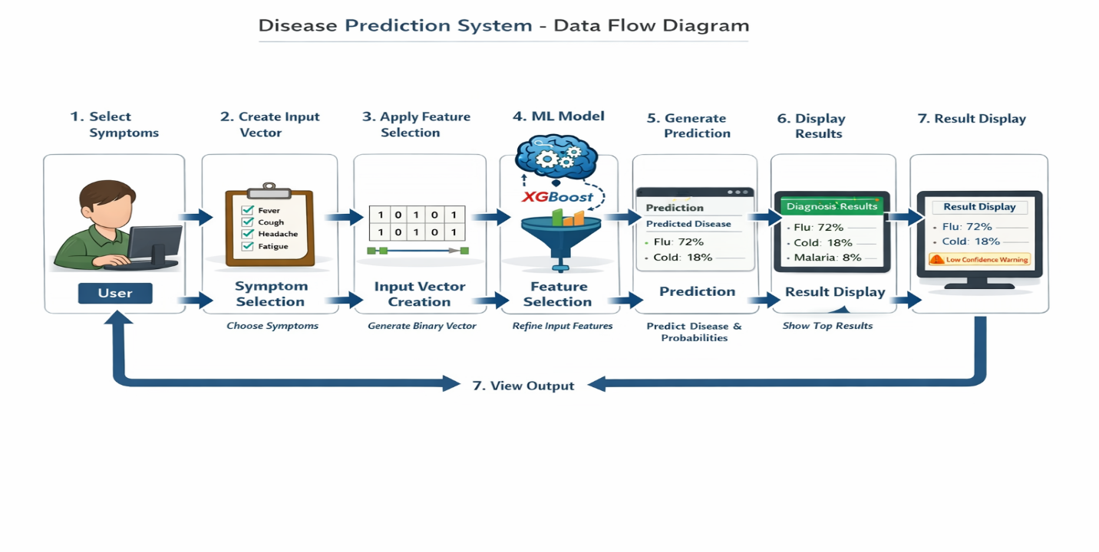

Data Flow:
- User selects symptoms
- System creates binary input vector
- Selector transforms features
- Model predicts disease
- Probability calculated
- Results displayed

5.3 Sequence Diagram

Streamlit UI
User

Select Symptoms
User

Click Predict
User

Create Binary Vector
UI

UI

Apply Selector

Call Model Predict
UI

Return Prediction
Model

Display Results
UI

6. TESTING
Testing is an important phase in the software development lifecycle. It ensures that the system works correctly, meets requirements, and produces accurate results. In the Disease Prediction System, both Unit Testing and Integration Testing were performed to validate individual components as well as the complete workflow.

6.1 Unit Testing
Unit testing focuses on testing individual modules or components independently to ensure each part functions correctly.
In this project, the following components were tested individually:

TEST CASE 1. MODEL LOADING FUNCTION

The function responsible for loading the trained model and preprocessing objects using joblib.load() was tested.

Objective:
- Ensure model files load without errors
- Verify correct objects are returned
- Confirm Streamlit caching works properly

Result:
Model and preprocessing files loaded successfully without runtime errors.

TEST CASE 2. INPUT VECTOR CREATION

This unit tests whether selected symptoms are correctly converted into a binary feature vector.

Objective:
- Verify selected symptoms are marked as 1
- Ensure non-selected symptoms remain 0
- Confirm vector length matches training features

Result:
Binary vector was generated correctly and matched the expected structure.

TEST CASE 3. FEATURE SELECTION TRANSFORMATION

The selector module was tested separately to ensure it properly transforms the input features.

Objective:
- Confirm correct feature reduction
- Ensure transformed input matches model’s expected format

Result:
Feature selection was applied successfully without altering data integrity.

TEST CASE 4. PREDICTION OUTPUT

The prediction function using model.predict() was tested.

Objective:
- Ensure correct disease label is predicted
- Confirm output type is valid

Result:
Model returned correct predicted class without errors.

TEST CASE 5. PROBABILITY CALCULATION

The probability prediction using model.predict_proba() was tested.

Objective:
- Verify probability values are generated
- Ensure probabilities sum to 1
- Confirm sorting logic works properly

Result:
Probabilities were correctly calculated and sorted in descending order.

UNIT TEST CASES

Test Case | Input | Expected Output
No symptom selected | Empty | Warning message displayed
Single symptom | Fever | Disease predicted successfully
Multiple symptoms | Fever + Cough | Higher confidence score
Invalid symptom | Not allowed | Option not selectable

Overall Result:
All individual units functioned correctly and passed the test cases successfully.

6.2 Integration Testing
Integration testing ensures that all modules work together as a complete system.
After verifying individual components, the entire workflow was tested from symptom selection to result display.

Tested Integration Scenarios

Model and Selector Compatibility
Verified that:
- The feature selector output matches the model’s expected input format.
- No dimension mismatch errors occur.

Binary Vector Consistency
Ensured:
- The generated binary vector structure is identical to the training dataset format.
- Feature ordering remains consistent.

Label Encoder Accuracy
Tested that:
- Predicted numeric label is correctly converted back to disease name.
- No incorrect mapping occurs.

Probability Sorting Logic
Confirmed that:
- Probabilities are sorted in descending order.
- Top 3 predictions are correctly displayed.

Confidence Warning Functionality
Verified that:
- Warning message appears when highest probability < 50%.
- No warning appears for high-confidence predictions.

End-to-End Workflow Testing
Complete flow tested:
- Symptom Selection
- Input Vector Creation
- Model Prediction
- Probability Calculation
- Feature Selection
- Label Decoding
- Result display
The system handled all steps smoothly without errors.
6.3 System Testing
System Testing is the final level of testing performed on the complete and integrated Disease Prediction System. It ensures that the entire application works correctly as a whole and meets the functional requirements specified during system design.
Unlike unit testing (which tests individual modules), system testing validates the complete workflow from user input to final result display.

Objective of System Testing
The main objectives of system testing were:
- To verify that the application runs without errors.
- To ensure correct interaction between frontend and backend.
- To validate prediction accuracy and probability calculation.
- To confirm that the user interface behaves as expected.
- To check system stability under normal usage conditions.

Testing Environment
System testing was performed under the following environment:
- Operating System: Windows
- Python Version: 3.x
- Libraries Used: Streamlit, XGBoost, Scikit-learn, Pandas, NumPy
- Browser: Google Chrome
- Hardware: 4GB RAM

Functional Testing
The following functionalities were tested:

1️. Application Launch
- Verified that the Streamlit application starts successfully.
- Confirmed that the model and preprocessing files load without errors.

2. Symptom Selection
- Checked that symptoms are displayed correctly in the multi-select dropdown.
- Ensured users can select multiple symptoms.
- Verified invalid inputs cannot be entered manually.

3.Prediction Process
- Confirmed that clicking the "Predict Disease" button triggers the prediction process.
- Ensured binary input vector is generated correctly.
- Verified feature selection is applied properly.
- Confirmed model generates prediction and probability scores.

4️.Result Display
- Checked that the predicted disease is displayed clearly.
- Verified top 3 diseases are shown with percentage probabilities.
- Confirmed probabilities are sorted in descending order.
- Verified low-confidence warning appears when probability < 50%.

5️.Disclaimer Verification
- Ensured medical disclaimer is displayed properly at the bottom of the page.

Non-Functional Testing

Performance Testing
- Application loads quickly.
- Predictions are generated within seconds.
- No noticeable delay during symptom selection.

Usability Testing
- Interface is simple and easy to understand.
- Users can operate the system without technical knowledge.
- Clear messages are shown for warnings and results.

Reliability Testing
- Application does not crash during repeated usage.
- Multiple predictions can be performed consecutively without errors.

End-to-End Workflow Testing
The complete system flow was tested:
User selects symptoms
→ System creates binary vector
→ Feature selection applied
→ Model predicts disease
→ Probabilities calculated
→ Label decoded
→ Results displayed
All steps were executed successfully without runtime errors

SOFTWARE IMPLEMENTATION

7.1 SOURCE CODE

App.py

import streamlit as st
import pandas as pd
import joblib
import numpy as np

# --------------------------------------------------
# Load trained model and preprocessing components
# --------------------------------------------------
@st.cache_resource
def load_model_and_components():
model = joblib.load("xgb_model.pkl")
selector = joblib.load("selector.pkl")
le_disease = joblib.load("label_encoder.pkl")
binary_features_columns = joblib.load("binary_features_columns.pkl")
return model, selector, le_disease, binary_features_columns

model, selector, le_disease, binary_features_columns = load_model_and_components()

# --------------------------------------------------
# Streamlit UI
# --------------------------------------------------
st.set_page_config(page_title="Disease Predictor", layout="centered")

st.title("🩺 Disease Predictor")
st.write(
"Select the symptoms you are experiencing, and the model will predict the most likely disease."
)

# --------------------------------------------------
# Symptom Selection
# --------------------------------------------------
st.subheader("Select Symptoms")

selected_symptoms = st.multiselect(
"Choose one or more symptoms:",
options=binary_features_columns
)

# --------------------------------------------------
# Prediction
# --------------------------------------------------
if st.button("🔍 Predict Disease"):
if not selected_symptoms:
st.warning("Please select at least one symptom.")
else:
# Create binary input vector
input_vector = pd.Series(0, index=binary_features_columns)
for symptom in selected_symptoms:
input_vector[symptom] = 1

# Convert to DataFrame and apply feature selection
input_df = pd.DataFrame([input_vector])
input_selected = selector.transform(input_df)

# Make predictions
prediction = model.predict(input_selected)[0]
predicted_proba = model.predict_proba(input_selected)[0]

# Sort probabilities (highest first)
probabilities = sorted(
zip(le_disease.classes_, predicted_proba),
key=lambda x: x[1],
reverse=True
)

predicted_disease = le_disease.inverse_transform([prediction])[0]

# --------------------------------------------------
# Display Results
# --------------------------------------------------
st.success(f"✅ Predicted Disease: **{predicted_disease}**")

st.subheader("📊 Top Predictions")
for disease, proba in probabilities[:3]:
st.write(f"**{disease}**: {proba:.2%}")

# Confidence warning
if probabilities[0][1] < 0.5:
st.info(
"⚠️ Prediction confidence is low. "
"Try selecting more symptoms for better accuracy."
)

# --------------------------------------------------
# Footer / Disclaimer
# --------------------------------------------------
st.markdown("---")
st.caption(
"⚠️ This tool is for educational purposes only and should not be used as a substitute "
"for professional medical advice."
)

Disease_Prediction.py:

import streamlit as st
import pandas as pd
import joblib
import numpy as np

# Load the trained model and other components
@st.cache_resource
def load_model_and_components():
model = joblib.load('xgb_model.pkl')
selector = joblib.load('selector.pkl')
le_disease = joblib.load('label_encoder.pkl')
binary_features_columns = joblib.load('binary_features_columns.pkl')
return model, selector, le_disease, binary_features_columns

# Load the resources
model, selector, le_disease, binary_features_columns = load_model_and_components()

# Streamlit UI
st.title("Disease Predictor")
st.write("Enter the symptoms to predict the disease.")

# Input Symptoms
all_symptoms = binary_features_columns
selected_symptoms = st.multiselect("Select Symptoms", all_symptoms)

if st.button("Predict"):
if not selected_symptoms:
st.warning("Please select at least one symptom.")
else:
# Create input vector
input_vector = pd.Series(0, index=binary_features_columns)
for symptom in selected_symptoms:
if symptom in input_vector.index:
input_vector[symptom] = 1
input_selected = selector.transform([input_vector])

# Make predictions
prediction = model.predict(input_selected)[0]
predicted_proba = model.predict_proba(input_selected)[0]
probabilities = {le_disease.inverse_transform([i])[0]: prob for i, prob in enumerate(predicted_proba)}

# Display results
predicted_disease = le_disease.inverse_transform([prediction])[0]
st.success(f"Predicted Disease: {predicted_disease}")
st.subheader("Prediction Probabilities:")
for disease, proba in probabilities.items():
st.write(f"{disease}: {proba:.2f}")

XG.py:

# Import necessary libraries
import pandas as pd
import numpy as np
from sklearn.model_selection import train_test_split, StratifiedKFold, RandomizedSearchCV
from XG import XGBClassifier
from sklearn.preprocessing import LabelEncoder
from sklearn.metrics import classification_report, f1_score
from sklearn.utils.class_weight import compute_sample_weight
from sklearn.feature_selection import SelectKBest, mutual_info_classif
from imblearn.over_sampling import SMOTE

# Load dataset
file_path = 'dataset.csv'
data = pd.read_csv(file_path)

# Step 1: Handle Missing Values
symptom_columns = [f"Symptom_{i}" for i in range(1, 18)]
data[symptom_columns] = data[symptom_columns].fillna("Unknown")

# Encode Diseases
le_disease = LabelEncoder()
data['Disease'] = le_disease.fit_transform(data['Disease'])

# Create binary presence/absence features
binary_features = pd.get_dummies(data[symptom_columns].stack()).groupby(level=0).sum()
y = data['Disease']

# Address Class Imbalance using SMOTE
smote = SMOTE(random_state=42)
X_resampled, y_resampled = smote.fit_resample(binary_features, y)

# Split the dataset
X_train, X_test, y_train, y_test = train_test_split(X_resampled, y_resampled, test_size=0.2, random_state=42)

# Compute sample weights for class imbalance during model training
sample_weights = compute_sample_weight(class_weight='balanced', y=y_train)

# Feature Selection
selector = SelectKBest(mutual_info_classif, k=50).fit(X_train, y_train)
X_train_selected = selector.transform(X_train)
X_test_selected = selector.transform(X_test)

# Model Initialization
xgb_model = XGBClassifier(random_state=42, eval_metric='mlogloss', use_label_encoder=False)

# Hyperparameter Optimization
param_dist = {
'n_estimators': [100, 200, 300],
'learning_rate': [0.01, 0.05, 0.1, 0.2],
'max_depth': [3, 5, 7, 10],
'colsample_bytree': [0.7, 0.8, 1.0],
'subsample': [0.8, 0.9, 1.0],
'min_child_weight': [1, 3, 5],
'gamma': [0, 0.1, 0.3],
'reg_lambda': [1, 10, 100]
}

random_search = RandomizedSearchCV(estimator=xgb_model, param_distributions=param_dist, n_iter=50,
scoring='f1_micro', cv=StratifiedKFold(n_splits=5), n_jobs=-1, random_state=42)
random_search.fit(X_train_selected, y_train, sample_weight=sample_weights)

# Best Model Evaluation
best_model = random_search.best_estimator_
y_pred = best_model.predict(X_test_selected)

print("Optimized Classification Report:")
print(classification_report(y_test, y_pred, target_names=le_disease.classes_))

# Prediction Function
def predict_disease(symptoms):
"""
Predicts the disease based on symptoms.
Args:
- symptoms (list of str): List of symptoms provided by the user.

Returns:
- str: Predicted disease.
- dict: Probabilities of each disease.
"""
# Create input vector
input_vector = pd.Series(0, index=binary_features.columns)
for symptom in symptoms:
if symptom in input_vector.index:
input_vector[symptom] = 1

# Example Usage
example_symptoms = ['itching', 'skin_rash', 'nodal_skin_eruptions']
predicted_disease, probabilities = predict_disease(example_symptoms)
print(f"Predicted Disease: {predicted_disease}")
print("Prediction Probabilities:")
for disease, proba in probabilities.items():
print(f"{disease}: {proba:.2f}")

7.2 SCREEN LAYOUTS

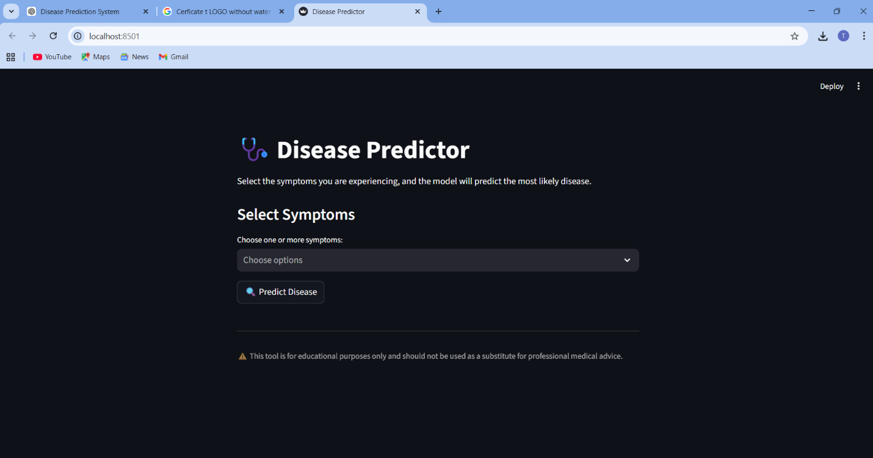

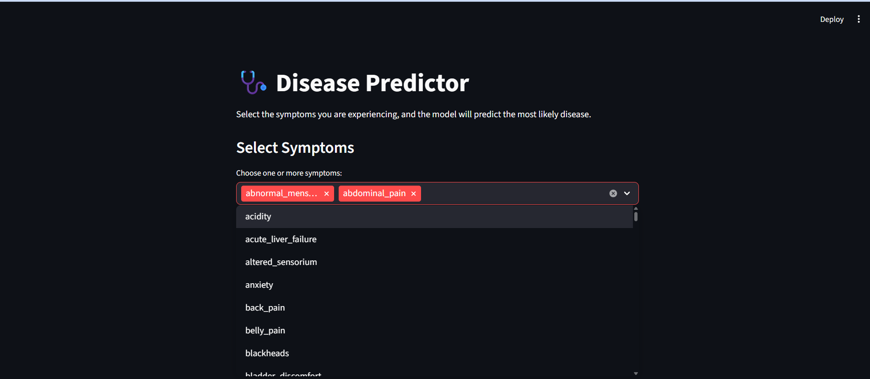

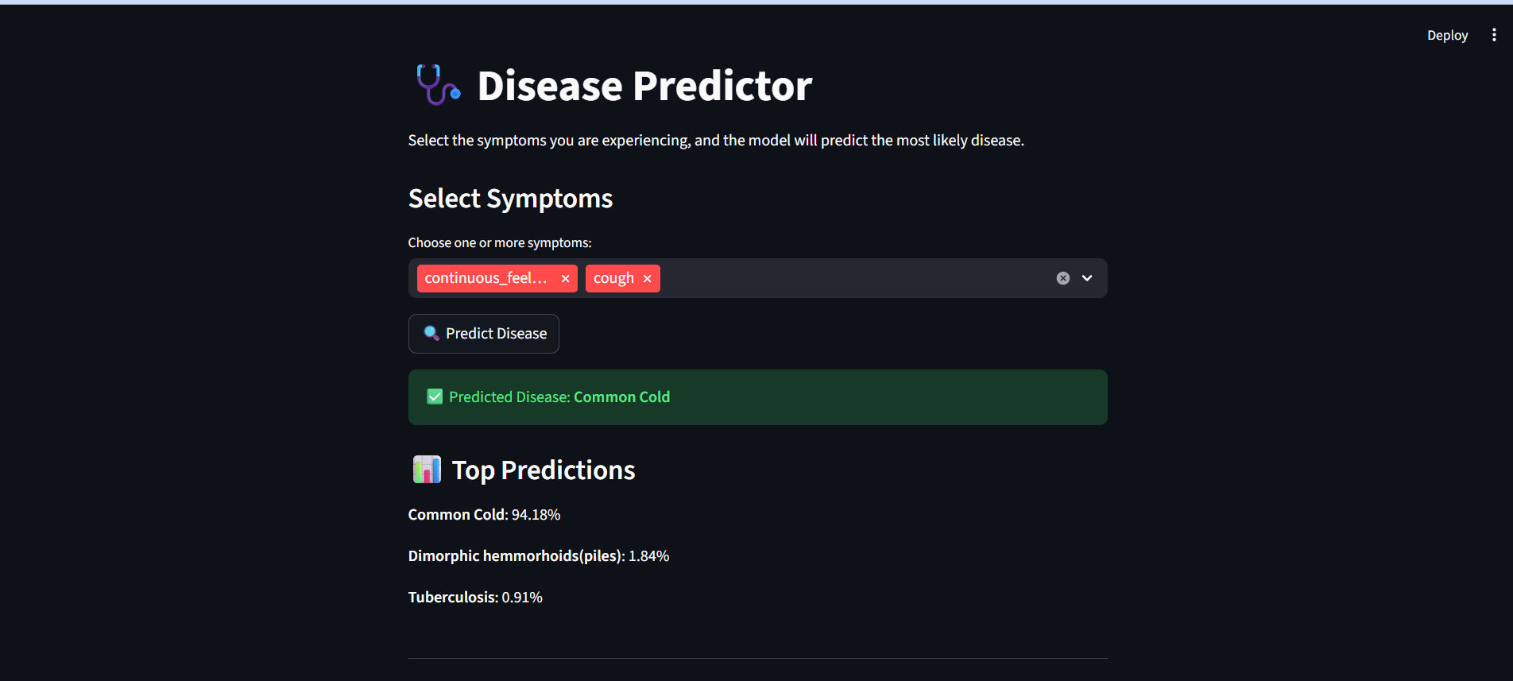

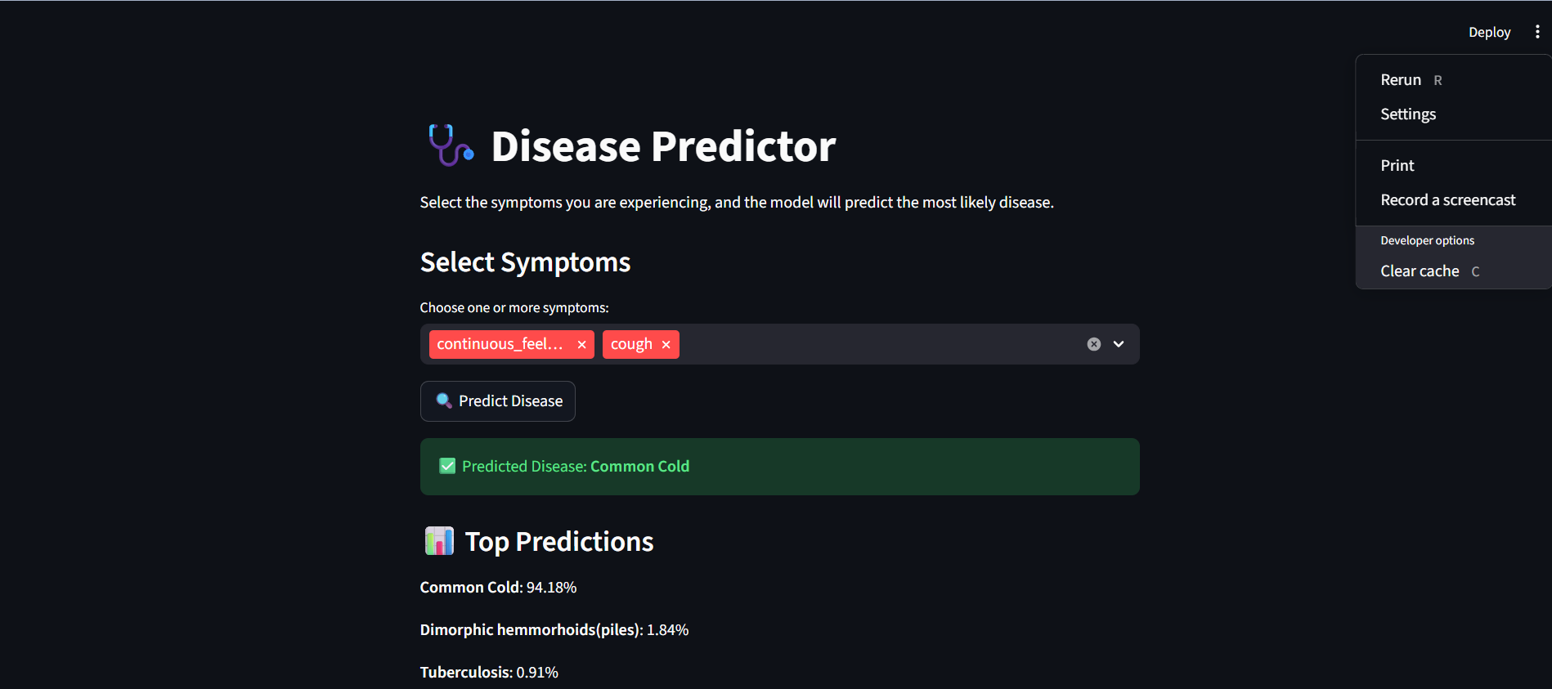

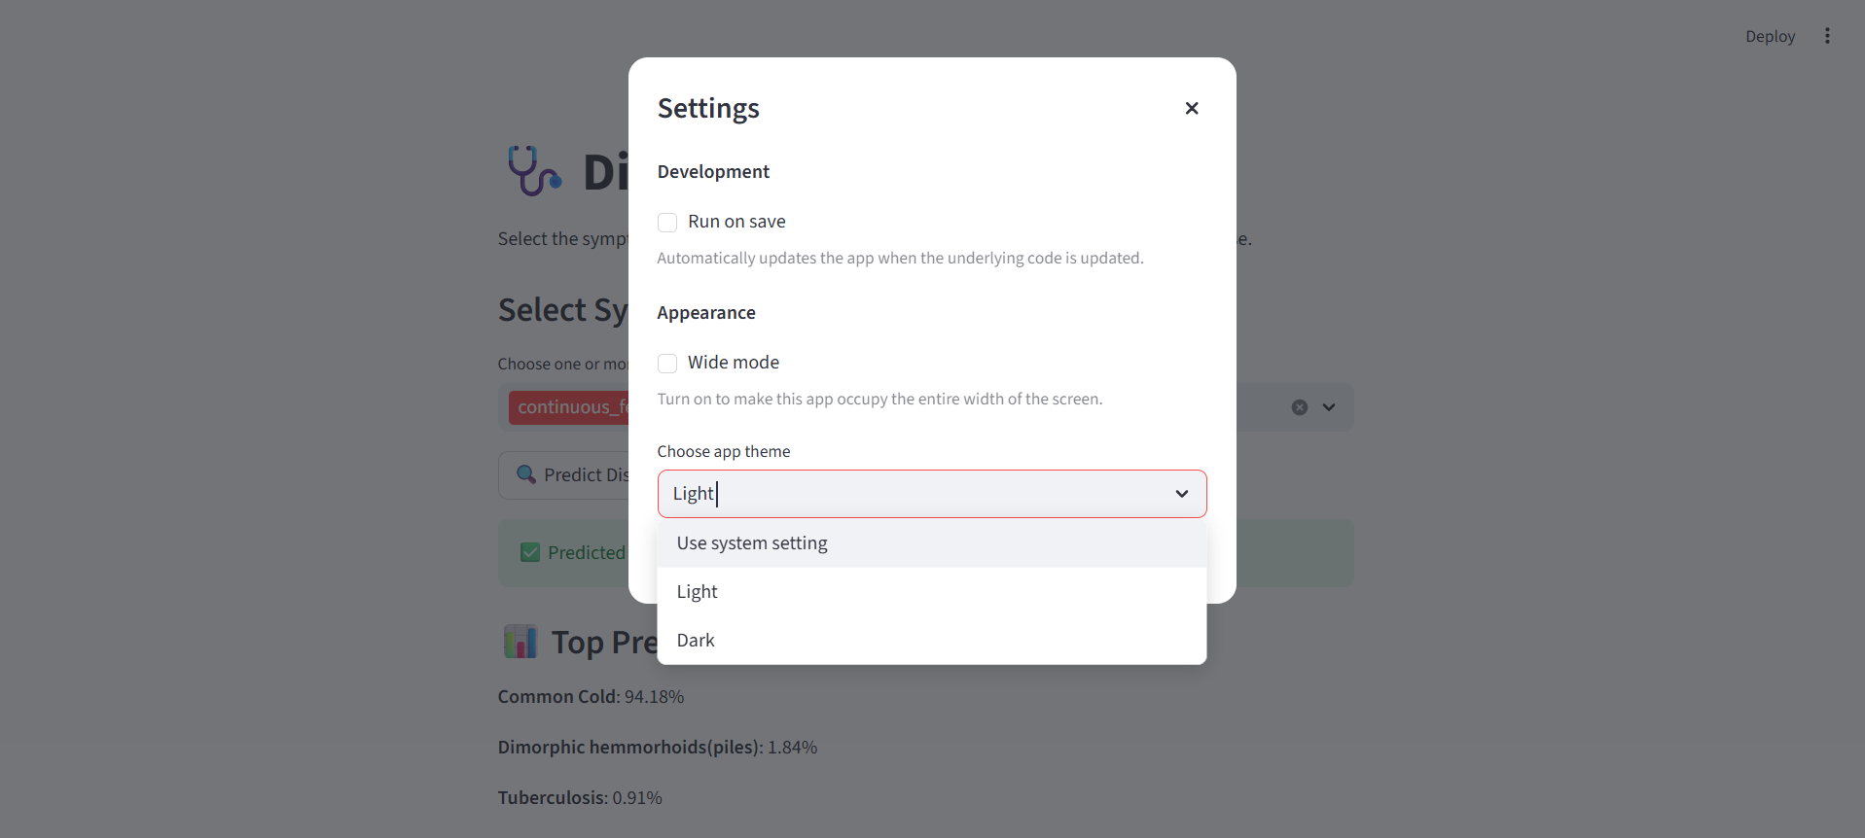

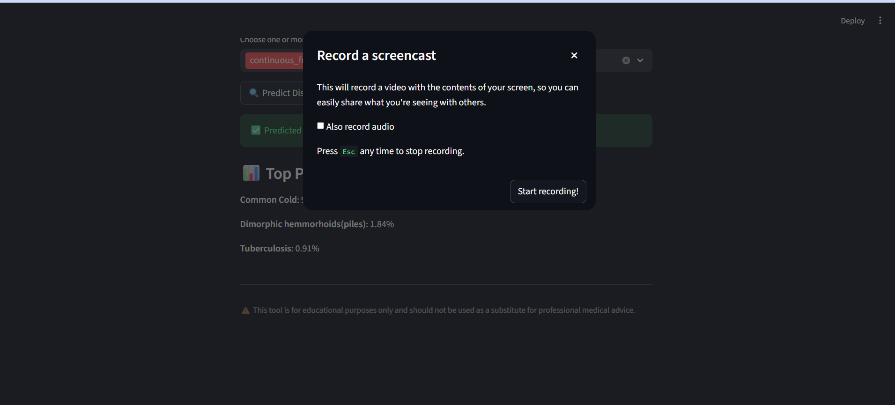

8. CONCLUSION
The Disease Prediction System successfully implements a machine learning–based approach to predict diseases based on user-selected symptoms. The system integrates data preprocessing, feature selection, trained classification models, and probability estimation to provide accurate and reliable predictions.
The application offers a user-friendly interface built using Streamlit, allowing users to easily select symptoms and receive instant predictions. The model analyzes the input symptoms, converts them into a binary feature vector, applies feature selection, and generates disease predictions along with probability scores. The top three probable diseases are displayed, along with a confidence indicator and medical disclaimer.
Testing results confirm that the system functions correctly at both unit and integration levels. All modules work cohesively without errors. The project demonstrates how machine learning can assist in preliminary health assessment and decision support.
However, this system is intended for educational and assistive purposes only and does not replace professional medical consultation.

9. FUTURE ENHANCEMENTS
The current system provides a strong foundation, but several improvements can enhance its accuracy, usability, and scalability:
- Larger and Real-World Dataset Integration
Incorporate real hospital datasets to improve prediction accuracy.
- Advanced Machine Learning Models
Implement deep learning models such as Neural Networks for improved performance.
- User Authentication System
Add login and patient history tracking features.
- Severity-Based Prediction
Include symptom severity levels instead of binary input.
- Natural Language Processing (NLP)
Allow users to type symptoms in plain English instead of selecting from a list.
- Mobile Application Deployment
Develop Android/iOS versions of the system.
- Doctor Recommendation System
Suggest nearby hospitals or specialists based on predicted disease.
- Cloud Deployment
Host the system on cloud platforms for real-time public access.
- Screen Recording and Report Download
Allow users to download prediction reports in PDF format.
- Multilingual Support
Enable support for multiple languages for better accessibility.

10. BIBLIOGRAPHY
- Han, J., Kamber, M., & Pei, J. (2011). Data Mining: Concepts and Techniques. Morgan Kaufmann.
- Géron, A. (2019). Hands-On Machine Learning with Scikit-Learn, Keras & TensorFlow. O’Reilly Media.
- Pedregosa, F., et al. (2011). “Scikit-learn: Machine Learning in Python.” Journal of Machine Learning Research, 12, 2825–2830.
- Streamlit Documentation. (2024). Available at: https://docs.streamlit.io/
- Python Software Foundation. (2024). Python Documentation. Available at: https://docs.python.org/
- UCI Machine Learning Repository. Disease-related datasets. Available at: https://archive.ics.uci.edu/
- Kaggle Datasets – Disease Prediction Dataset.

